**PARADE USER GUIDE**

**Path Planning**



**Version 1.61 Oct 2021**

**Version History**

|  |  |  |  |
| --- | --- | --- | --- |
| **Version** | **Date** | **Author** | **Comments** |
| 1.60 | Sep 2021 | K.Wilson | Original Version |
| 1.61 | Oct 2021 | K.Wilson | Updated with graphics dialog |

Contents

Overview 1

Path planning 1

Vertical well 3

2D Build and hold 4

2D Double Turns 5

3D Automatic path 6

3D manual paths 7

Extend with straight line 9

Extend with single turn 9

Extend with a double turn 9

Continue on curve 10

Error messages 10

# Overview

Path planning was added to Parade in version 1.60. It allows the creating of a planned path consisting of “ideal” sections of straight lines and curves.

A path created this way can have simulated tortuosity added to give a more realistic calculation path for use in the calculations of Torque and Drag, Hydraulics and so forth.

# Path planning

The path planning dialog is opened from the Well path edit table in the Scenario menu.

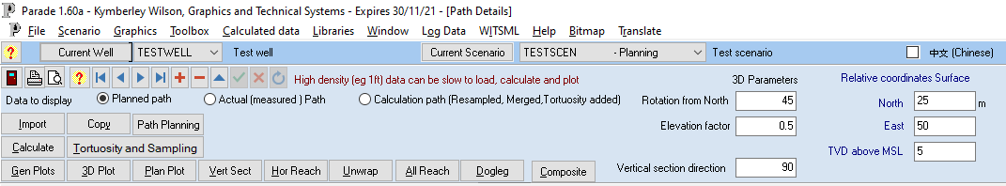

Before it opens, a check will be made that all the default plots have been defined and include a planning curve on each graph. If not, they will be created, replacing any existing plot definitions. The form by default opens with the Composite plot displayed, if a planning path already exists.

Be aware that, apart from the Existing path option, any calculation will replace this path with a new one.

The plot will be scaled to the largest size that fits both horizontally and vertically in the plot panel.

The side panel displays the Start options.

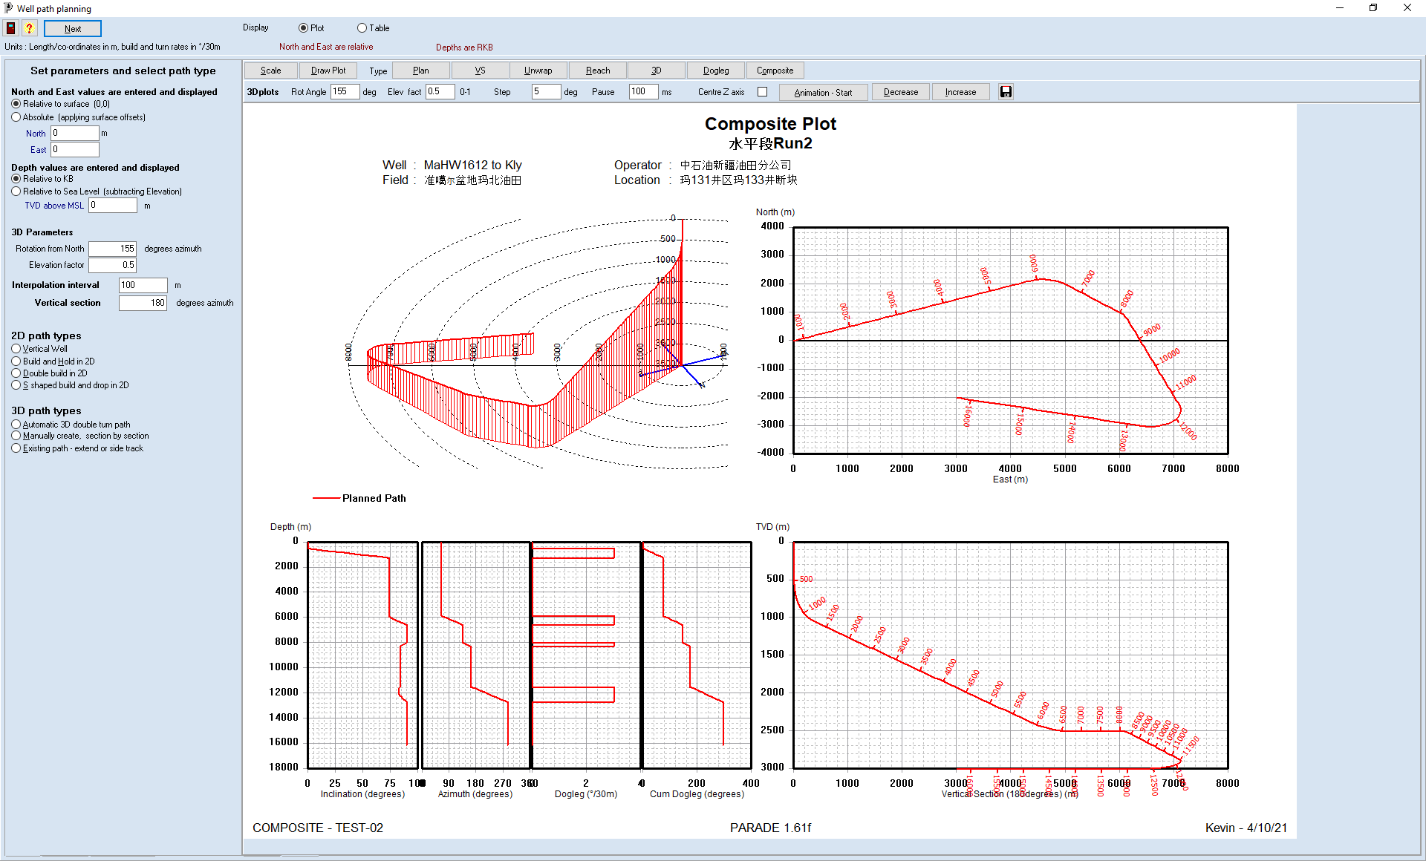

The Start options allow the path to be expressed as relative values, ie from surface (0,0,0) or using the North and East offsets from a reference point and either from the Drill floor (Kelly Bushing) or MSL.

Those offsets can be defined when selected.

In addition, the Interpolation interval, Vertical section azimuth and the 3D parameters are defined on this panel.

Any changes to the values are saved when a path type is selected.

The path types that are available in Parade are grouped into 2d and 3D paths.

The 2d paths include a vertical well, a single build and hold, and double turns, both “build and build” and “build and drop”.

Each of these has a different set of parameters entered in to the appropriate calculation panel. Depths and distances measured along the hole are referred to using the term MD, and those in the vertical direction via the term TVD.

The 3D choices include an automatically double turn path - ie a build to a tangent from a vertical kick off, then a turn to a target - or a manually created path. To start from scratch, use the Manually create option or to add to or modify an existing path use Existing Path.

When a path type that will create a new path is selected, a warning will be given that the existing path will be deleted.

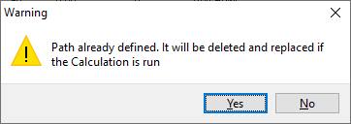

To return to the Start panel click the Back button that appears below the table.

Running the calculation also removes the fixed scaling of the plots so that scales will be recalculated to match the new path limits when each plot is displayed.

Once the calculation finishes the table and selected plot will be updated

Each path table consists of the key points, which include Surface, Kick off points, End of build points, Targets, TD etc. In addition, points on the lines and curves between the Key points are added at multiples of the interpolation interval. These interpolate points can be hidden by checking the “Show only key points…” check box under the table.

## Vertical well

The simplest well is a vertical one. In this case, only the TVD depth at TD needs to be specified.

This calculates a point at (0,0,TD) and then interpolates at the specified interval.

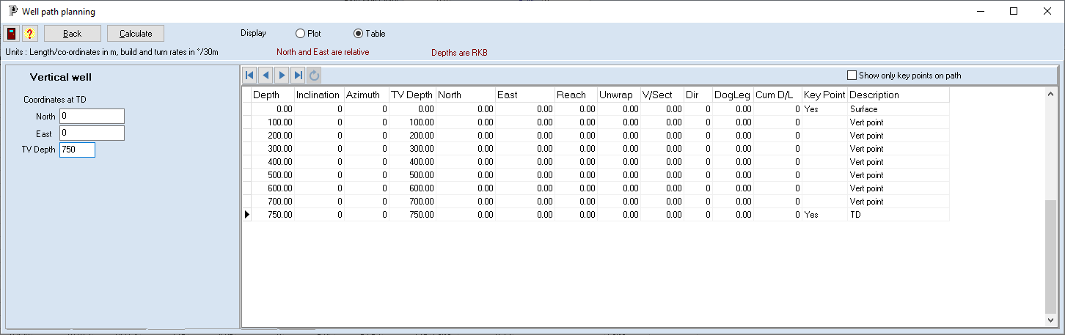

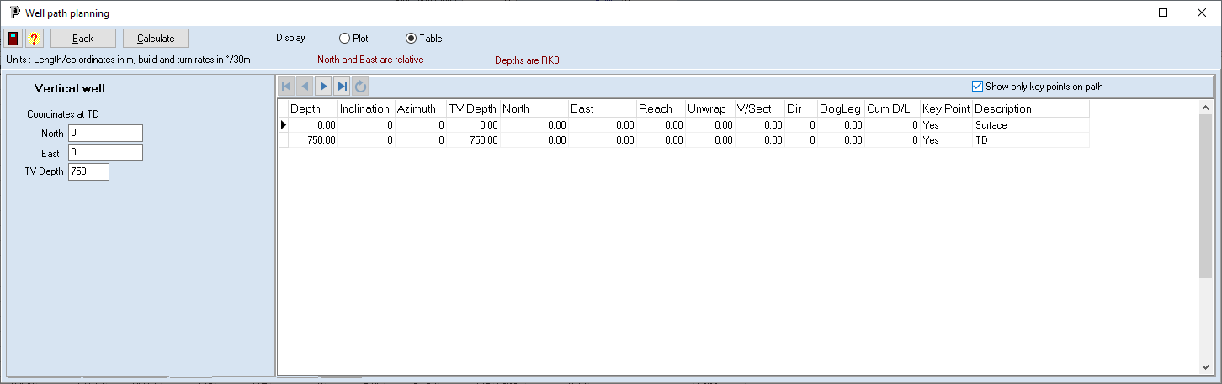

The plots of a vertical well are not very interesting.

## 2D Build and hold

A “build and hold” path is another simple path. The path is kicked off from a vertical section, built in a single vertical plane at a fixed build rate and then continues at a tangent to TD.

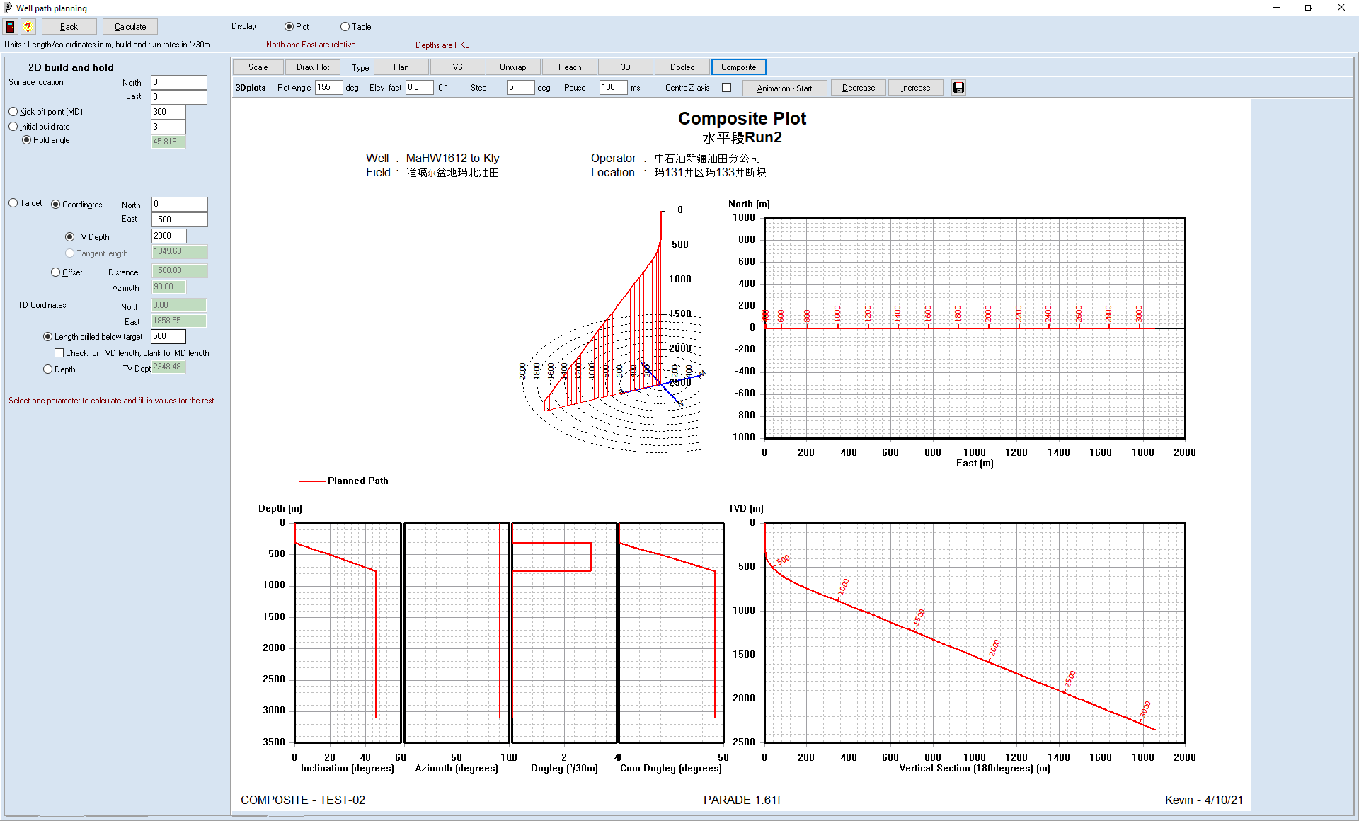

The critical parameters for this type of path are the Kick of point, build rate, Hold angle and target offset. However only 3 of these parameters can be defined since the 4th is derived from the other 3.

The calculated parameter is selected and the other 3 entered. After the calculation is complete the calculated values are filled in.

In addition, the target offset can be defined in 2 ways. Either as North and East values or as by specifying the distance and direction as an azimuth. The Vertical position of the target is specified as a TVD value or, for the offset case as a tangent length. Ie the hold distance from the end of the build to the target.

The TD is defined assuming path continues from the target in a straight line at the same inclination and azimuth. This can be defined as the length drill in Measured or TVD length or as an actual TVD.

## 2D Double Turns

The “Double Build” and “S shaped build and drop” paths use essentially the same parameters and the same calculations. Again, the path lies in a single vertical plane, so the plan plot is a straight line.

The difference between the 2 is that in the double build the final inclination is greater than the hold angle, while in the build and drop it is smaller.

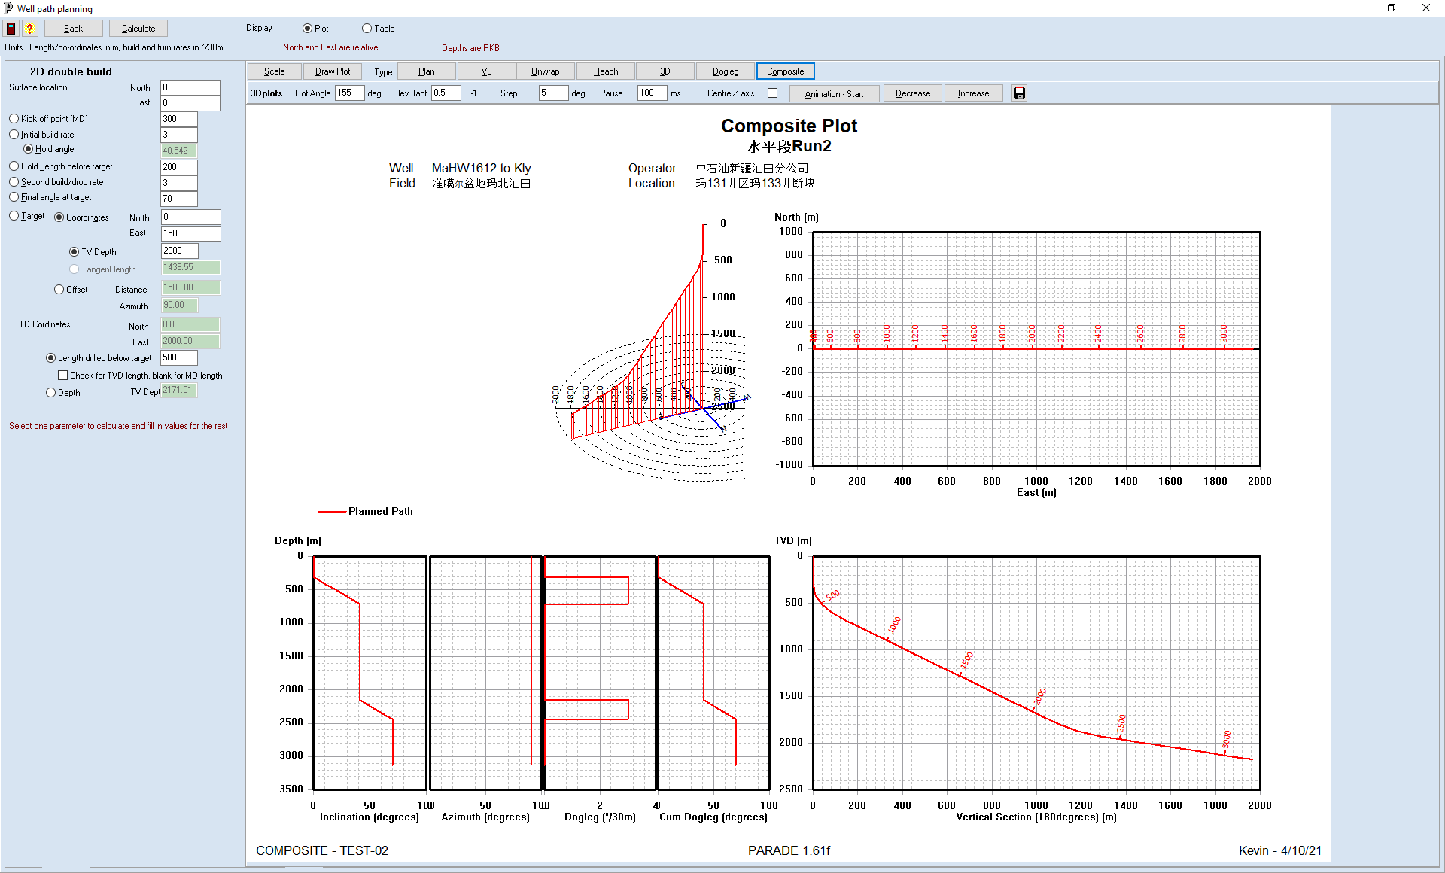

The parameters are the same as the build and hold plus 3 extra parameters to define the second turn. These specify the hold length between the end of the second turn and the target, the second build rate and the final inclination.

There are relationships between the parameters that means that one of them is completely defined and is derived from the others.

As in the previous case, the path can be extended below the target in a straight line to TD.

## 3D Automatic path

This is again a double turn path, but in this case the target does not need to be in the same vertical plane as the initial build and hold.

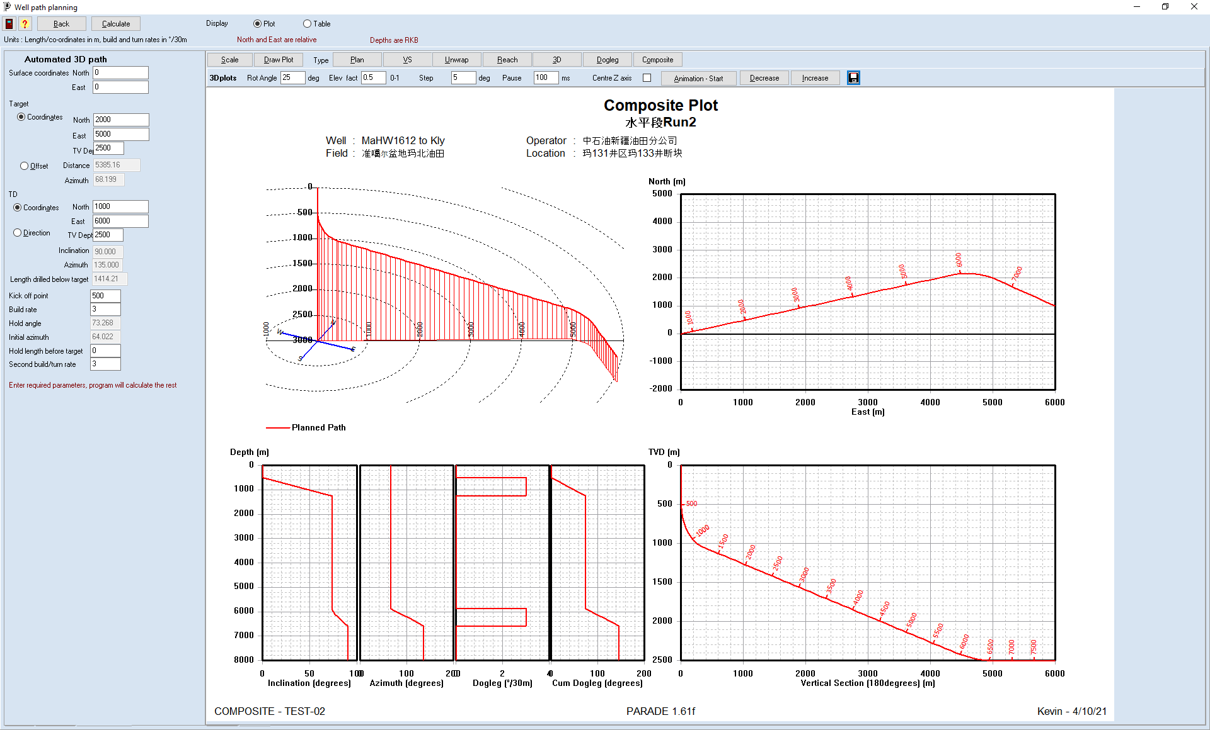

In this form, the first turn is a build and hold and then a turn is made to get to the target which may have changes to both the inclination and the azimuth. The path can then be extended in a straight line below the target to TD.

The coordinates for both the target and TD can be defined by North, East and TVD or Distance, azimuth and TVD for the target and distance, inclination and Azimuth for TD. The line from target to TD defines the inclination and azimuth through the target.

In addition, the straight lines before and after the curves are defined by the kick off point and the hold length before the second target, as well as the build rates for the 2 curves.

## 3D manual paths

The Manual 3D path and the Existing path modifications both use the same form.

The different is that the former will start defining the path from the surface and hence completely replace the existing path, whereas the later will by default add to the end of the existing path.

However, once the dialog is displayed the functionality is the same.

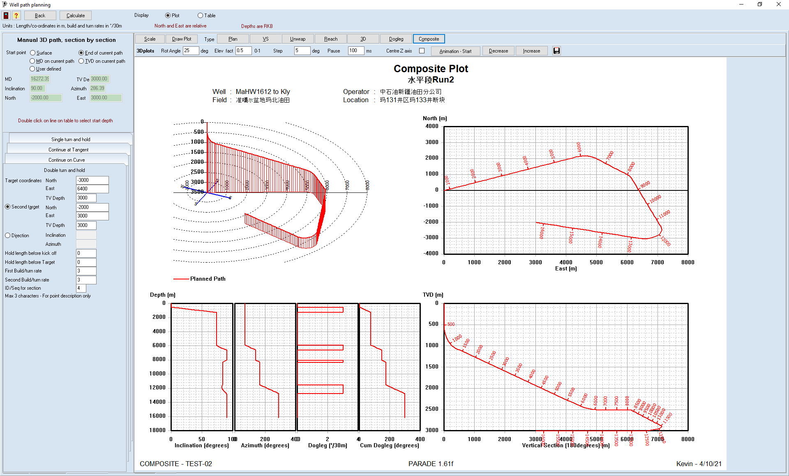

The start point for the section of path to be added is select by from several choices.

Surface or End of path are the 2 defaults but for a side-track or a redefinition of a section an MD or TVD depth can be manually entered and the [Calculate start values] button will appear to determine the remaining start parameters from interpolation.

Alternatively, the user defined option allows all parameters for the start point to be manually entered.

As a short cut, double clicking on a line in the table will select that point as the start of the new section.

When the calculation is run, any point from the start point onwards will be deleted from the existing path and then the new path added.

Quite complicated paths can be created using this option.

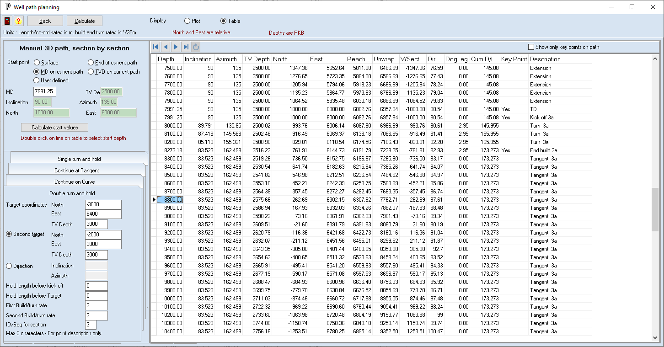

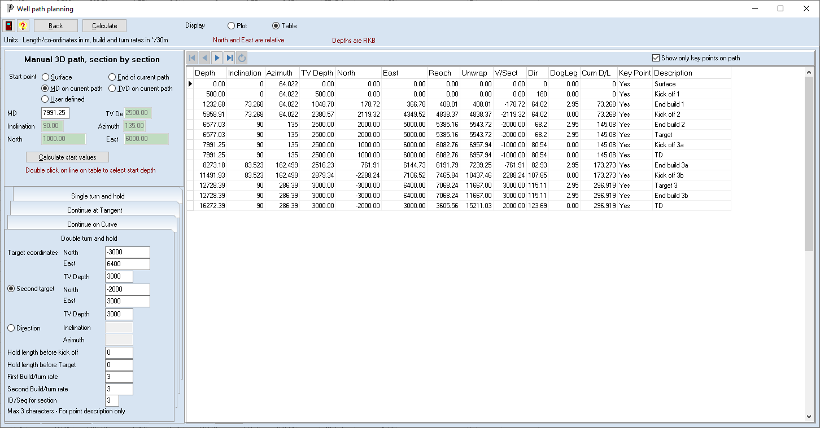

4 different types of extensions can be created.

### Extend with straight line

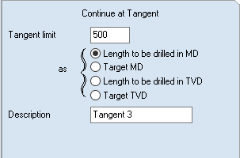The path continues from the start point with the same inclination an azimuth.

The length of the line is specified as a value which can be the length or target depth in either MD or TVD.

A description for the description can also be defined.

### Extend with single turn

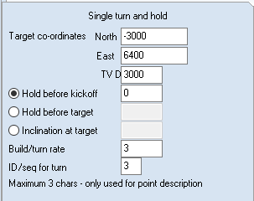This adds a single turn build and hold section. Initially a straight section is added at a tangent and then a curve made to the target.

In this case only one of the Hold before kick off, Hold before target or Inclination at the target can be specified. The build rate is specified as well as the ID for the turn, used in the description

Note that it may not be possible to reach the target with a single turn.

### Extend with a double turn

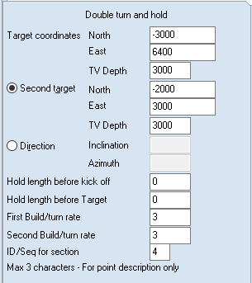This adds a double turn section. Initially a straight line section is added then a turn, a line and another turn followed by a line through the target and the second target.

Both targets can be defined by North East and TVD values with the second target have the option to use direction and TVD instead.

The hold before kick off and target and the 2 build rates must also be defined.

An ID for the description can be entered.

### Continue on curve

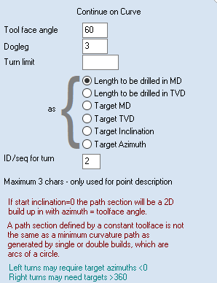This extension, unlike the others starts with a curve.

In addition, instead of a minimum curvature calculation, this option uses toolface and dogleg. If the toolface is 0 degrees, then the curve is an arc in the vertical plane and if it is +/- 90 degrees it is an arc in the horizontal plane. Otherwise it is a section of a spiral.

The curve starts with the existing inclination and azimuth and continues on the curve until it reaches a limit. This can be the length of the section or the target depth in MD or TVD or a target inclination or azimuth.

An ID can also be entered.

## Error messages

Not all sets of parameters will allow the selected path section to be calculated. As a trivial example with a horizontal extension the target TVD must match the existing one for it to be successful.

The double turns are calculated using an iterative technique to find start and end points for the intermediate turn. This may not converge after a certain number of iterations.

When a solution cannot be found a message will be displayed with a suggestion on what changes may be required to achieve a viable solution, eg changing the inclination or build rates.